Brief Analysis of Harper’s Island

**Introduction**

Harper’s Island is a one-season American mystery horror show that ran on CBS from April 9, 2009 to July 11, 2009. It is about a group of family and friends going to an island, Harper’s Island, for a wedding. However, one by one the characters started dying, and there is a killer amongst the attendees. The wedding ceremony obviously did not go as planned and the goal is to find the killer and stop them.

I was 10 – 11 years old at the time of the show and loved it. However, I remembered they switched to showing new episodes on Saturday nights rather than Thursday nights, which is primetime for CBS, in my opinion. I also noticed that there wasn’t a lot of traction on the show back then. Not much was mentioned on the internet back in 2009. Ended up re-watching all 13 episodes this past January. I always thought it was underrated, so this data is to explore how others rated the show and compare it with how many views it had and maybe understand its fall-out. Please keep in mind, this is solely my opinion based on the data given and what I saw in the show itself.

**Methodology**

I used IMDB ratings for the ratings of each episode and as for views I used the show’s Wikipedia article which generated the views from TVTango, the only site that shows how many people viewed a specific episode. I plotted everything on RStudio. The objective was to see the relationship between viewership and ratings for each episode and what it can indicate. IMDB is the only site that provides ratings for each episode. Keep in mind, each episode has a different number of raters. Lowest is 293 ratings (Episode 7,8, 9). Highest is 478 (Episode 1). The rest of the episode were rated by somewhere between 300 and 370 people – a decent sample size that could represent the population. Furthermore, the average across all ratings in IMDB were only taken into consideration.

**Results**

The words below each plot on the left is the episode’s name.

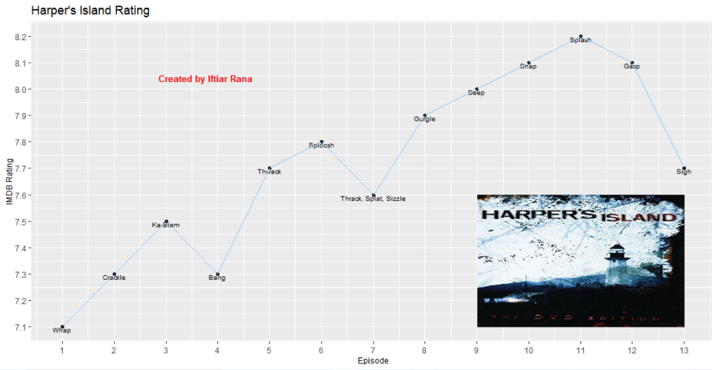

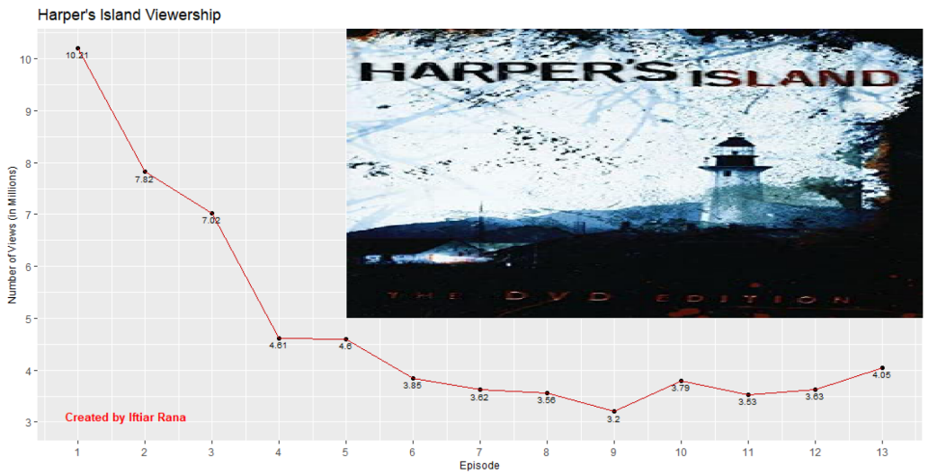

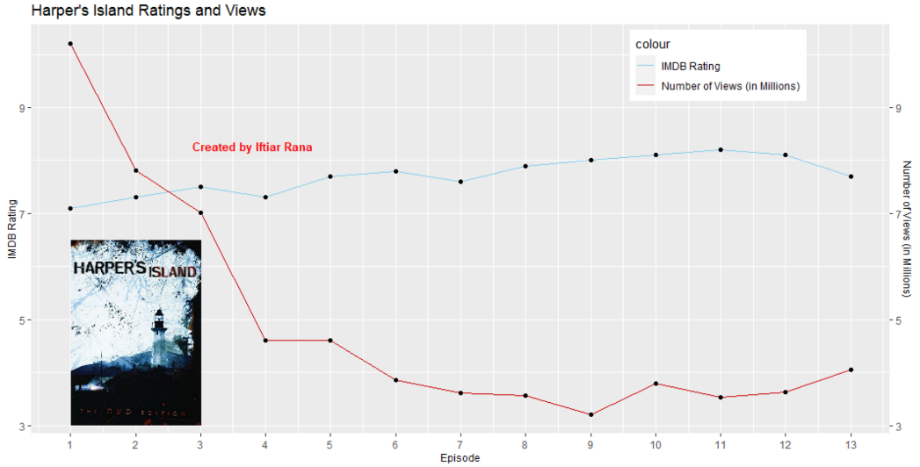

I apologize if the graphs look a bit weird. For the “Harper’s Island Rating” graph, I tried doing it on a 0 to 10 scale, but it looked unpleasant and none of the scales numbers besides 8 were showing up. I also chose to plot 2 y-axes in the “Harper’s Island Ratings and Views” graph just for neatness and readability. I didn’t want to write “IMDB Rating/Number of Views (in millions)” on one axis.

**Conclusion**

I noticed the decline in number of views for majority of the episodes. Honestly, it is understandable why people stopped watching. It was painstakingly slow, building up the tension for too long. With a big cast (25 people at the start), it was pretty hard to kill one-by-one with only 13 episodes. Therefore, some character development and characters had to be prematurely stunted and there had to be episodes where multiple characters die, which could be too fast for viewers. There is always at least one death in each episode. The directors and producers wanted to build suspense but wasn’t able to balance between suspense and maintaining audience engagement given their 13-episode constraint. However, it does pick up pretty fast towards the end and gets more intense & suspense. It could be a reason why the number of views slightly increased after episode 9.

From the double-axes graph that has both ratings and number of views, I noticed that while views for the most part decreased, ratings overall increased. It could indicate that those who stuck around and saw the show from start to finish think it’s very underrated. At least that’s my opinion. The premise of Harper’s Island is tantalizing and the format is basically taking a murder/slasher movie and making it into a show. However, it may have been a bit ahead of its time. Now there are other shows that uses a similar, if not the same format – American Horror Story, Castle Rock, and Into the Dark to name a few.